**What is Power BI?**

Microsoft Power BI is a self-service business intelligence platform which includes both desktop and web based applications for connecting, modelling and visualizing data.

It allows users to create interactive reports and dashboards, making it easier to understand and analyze information for better decision-making in organizations.

It allows users to connect multiple data sources. It is a powerful tool for data analysis and visualization.

**Advantages:**

* Makes easy for businesses to spot trends, track performance and make data driven decisions
* Real-time information
* Frequent and consistent updates
* Integration with a wide array of data sources
* Excel integration

**Why power bi?**

* It can connect, transform and load millions of row data.
* Build relational models to blend data from multiple sources.
* Define complex calculations using Data Analysis Expressions (DAX).
* Bring data to life with interactive dashboards and reports.

**Applications of power bi :**

**Visualizing data:**

Power BI tools allow users to visualize key data points from various sources in a single dashboard.

**Creating dashboards :**

Power BI contains dashboarding functions that can help users automate their work and create visuals for complex data.

**Generating reports :**

Power BI can help users generate charts and other visual reports to get instant feedback.

**Collaborating**

Power BI allows users to create collections of dashboards, workbooks, and paginated reports that have a common purpose into workspaces. Users can also share ownership and manage reports, dashboards, datasets, and workbooks.

**Linking to applications**

Power BI can be linked to applications by authenticating using Azure AD. This allows users to get real-time insights about their application on the Power BI dashboard.

**Install Power BI desktop**

1. Through Microsoft store.
2. Through web

[**www.powerbi.com**](http://www.powerbi.com)

**SSTE**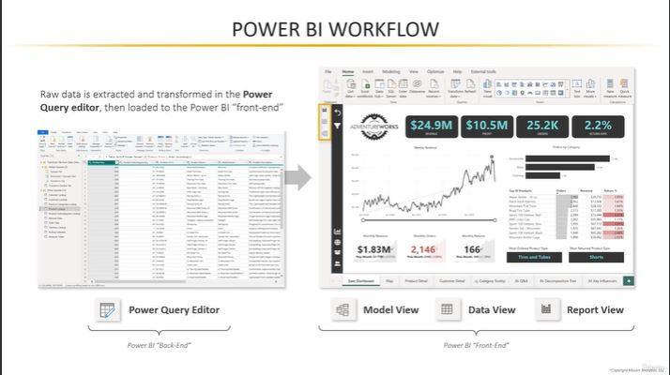

**Steps need to perform:**

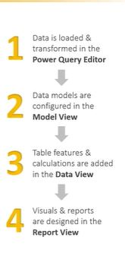

**Extract:** we can extract or get data from various sources like excel, sql, notepad, and various platforms. Through sql we can extract data by two ways: import and direct query.  
**Import:** by using this directly we can import data from sql by giving credentials .it has benefit of showing metadata in the table view

**Direct query:** by using this,we unable to see meta data(table info) But we create reports based on sql statements that we provided while extraction.it mainly used for large data sets where we can apply conditions to filter the data.

**Power bi dashboard:**

1. **Report view:** it is used to create reports on tables on the right side tables that can be shown as data. And we can see filters and visualization tabs.
2. **Table view** : extracted data can be shown in the form of tables
3. **Model view:** it gives relationships between the tables

Power bi in and as front-end and backend

**Front-end:** it includes data, model and report where modelling, analyzing and visualization takes place.

**Back-end:** it includes power query editor where raw data is extracted, transformed and loaded to the front-end in the (ETL) format.

**Power query editor**

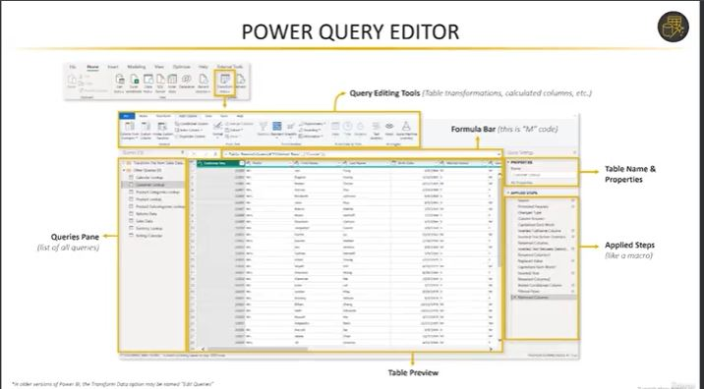

Basic query tools:

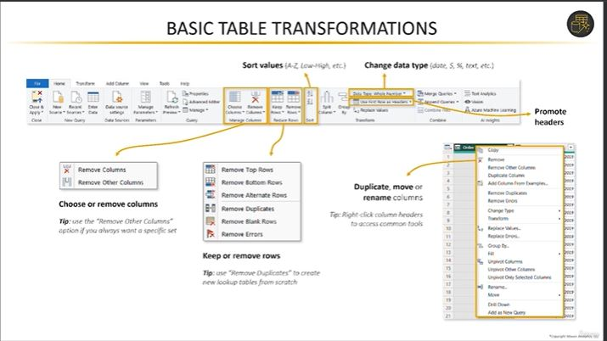

Query editing tools:

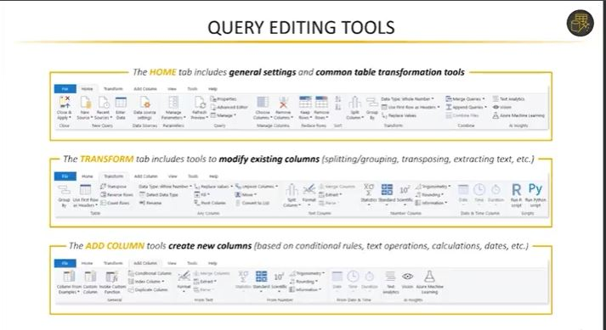

**Power query editor**

By clicking transform data we go to the power query editor window . It shows data as a query . It can be used to transform or modify data from the tables. We can do various modifications to our data like Adding, removing columns. And rows as well.Here we have various options for manipulating our data to our requirements. We can change data types , perform mathematical operations like round, duplicate columns, extract year, month,date from the date.

**Append:** it has two ways

1**. Append query**: it uses the existing table and joins other tables.

2**. Append query as New:** it creates a new query for joining the table.

It means join of tables the tables should be the same structure .should have the same column name and datatype. The data can be the same or different by using basic we can join only 2 tables. But by using advanced we can join multiple tables .After joining we can also perform aggregate functions.

**Transform tab:**

In this tab we can perform a transpose operation which means interchanging of rows and columns rows will be changed as column and vice-versa but the data will not be changed.

**Transpose:** interchanging of rows and columns

**Reverse rows**: it reverses the order of rows

**Count:** it gives the total count of rows present in the query.

**Pivot column:** rearranging information to make it easier to understand. It's like turning rows of data into columns. It is like changing the perspective of your data to get a better picture.